Master Theory Document A to Z
Online Retail Customer Segmentation with K-Means, DBSCAN, Hierarchical Clustering and Business Rules
Scope: Covers all five Learning Day 8 notebooks and the official MVD checklist for clustering with K-Means, DBSCAN, Ward hierarchical clustering and Gap Statistic.

1. Clustering foundation
Clustering is unsupervised learning. The model does not receive a target label. It tries to find natural groups based on customer behaviour. In this project, each customer is represented by RFM behaviour: Recency, Frequency and Monetary value.
Concept | Simple meaning | Project use
Unsupervised learning | Learning patterns without target labels | Customer segmentation has no pre-existing customer group label
Cluster | A group of similar customers | Used to group Online Retail customers by RFM behaviour
Distance | How far customers are from each other in feature space | Core idea behind K-Means, DBSCAN and hierarchical clustering
Scaling | Putting features on a comparable scale | Required because R, F and M have different units

2. RFM theory
RFM is a customer analytics method that summarizes purchase behaviour into three values. Recency measures how recently a customer purchased. Frequency measures how often they purchased. Monetary value measures how much they spent.
Feature | Meaning | Business interpretation
Recency | Days since last purchase | Lower recency usually means more recent engagement
Frequency | Number of purchases or purchase events | Higher frequency means stronger buying habit
Monetary | Total spend | Higher monetary value indicates stronger revenue contribution

3. PCA theory for visual maps
PCA compresses multiple numerical features into fewer visual dimensions. In this project, PCA is used only for plotting. The clustering models still use scaled RFM values. The first two PCA components explain 88.96% of the scaled RFM structure, which makes the 2D map useful for visual checking.

4. Partitioning methods
Method | Theory idea | Project use
K-Means | Creates exactly k groups using centroids | Main segmentation baseline
MiniBatchKMeans | Faster K-Means using small batches | Speed comparison
K-Modes | Clusters categorical features by matching categories | Country, product and RFM category view
K-Medoids / fallback | Uses real representative customers instead of centroids | Robustness comparison
K-Prototypes | Combines numeric and categorical features | Mixed data clustering view

K-Means requires a chosen k. The project tested k=3, k=5 and k=7, then used both metrics and business readability to select k=5 as the main baseline.

5. Outlier detection theory
Outliers are customers that behave very differently from the majority. In retail data, outliers are not automatically bad. They may be VIP buyers, wholesale customers, inactive edge cases or data quality cases. The project used top 1%, IQR, Isolation Forest and Local Outlier Factor to mark strong outliers.

6. Density-based clustering theory
Concept | Theory idea | Project use
DBSCAN | Dense areas become clusters; far-away points become noise | Finds dense groups and 63 noise customers
eps | Neighbourhood radius around a point | Tested 0.5, 1.0 and 2.0
min_samples | Minimum neighbours needed for a dense area | Tested 3, 5 and 10
OPTICS | Explores density across multiple levels | Exploration; too strict for final segmentation
DENCLUE-style KDE | Scores customer density with a smooth density estimate | Supporting density score layer

7. Grid, Wave and subspace theory
Grid methods divide the customer map into boxes and count customers in each box. STING summarizes grid cells. WaveCluster-style smoothing makes broader dense regions visible. CLIQUE-style subspace checking looks for dense patterns in two-feature spaces, such as Recency + Frequency or Frequency + Monetary.

8. Hierarchical clustering theory
Hierarchical clustering starts with each customer as its own group and repeatedly merges the closest groups. Ward linkage merges groups in a way that tries to keep within-cluster variance low. A dendrogram visualizes these merge steps.
Term | Simple meaning | Project interpretation
Ward linkage | Merge groups while minimizing within-cluster variance | Used for agglomerative hierarchical clustering
Dendrogram | Tree showing how groups merge | Supported a practical k=3 choice
Merge distance | How different groups are when merged | Large jump shows a natural cut point
Cut threshold | Height where the dendrogram is cut | Cut around 27.62 produced 3 clusters

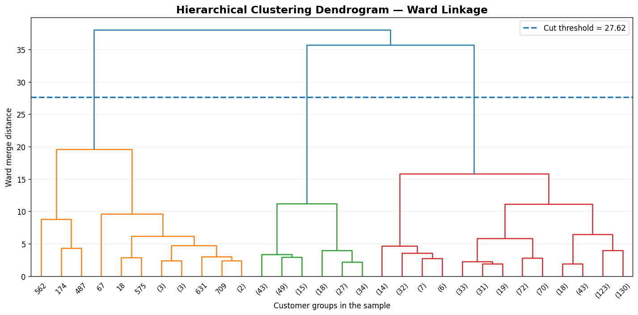
Dendrogram theory in practice: large merge-distance jump supports k=3.

9. Gap Statistic theory
Gap Statistic compares clustering on real data against clustering on random reference data. If the real clusters are much better than random clusters, the Gap value is larger. In this project, the raw Gap was highest at k=8, but the practical hierarchical choice remained k=3 because the dendrogram and business readability supported it better.
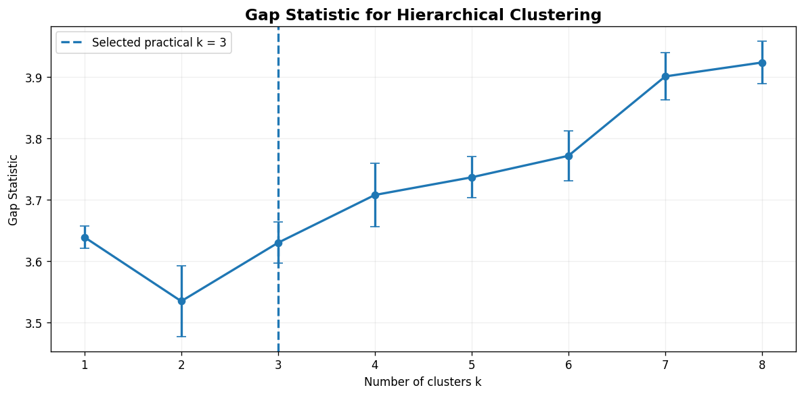
Gap Statistic results with selected practical k=3 marked.

10. Evaluation metrics theory
Metric | Good direction | Meaning
Silhouette | Higher is better | Customers are close to their own cluster and far from other clusters
Davies-Bouldin | Lower is better | Clusters are compact and not too mixed
Calinski-Harabasz | Higher is better | Overall cluster separation is strong
Inertia | Lower with caution | K-Means within-cluster spread; always decreases as k increases

11. Business-rule theory
Models find patterns, but business teams act on meaningful labels. Constraint-based segments keep the model result but override special cases using business logic, such as VIP outliers and inactive low-frequency customers.

12. Method selection guide
Business question | Best method | Reason
Can we create stable customer groups? | K-Means | Simple, explainable and campaign-friendly
Which customers are unusual? | DBSCAN + outlier flags | Keeps noise and extreme customers visible
Do clusters have hierarchy? | Ward hierarchical clustering | Shows merge structure and natural splits
How many clusters should we test? | Elbow + Gap + dendrogram | Combines multiple diagnostics
Where is customer density strongest? | Grid, Wave and KDE | Explains concentration areas visually
How do we make clusters actionable? | Constraint rules | Adds business logic on top of model labels

